Milestone 4
Create onSubmit Client Script – Save Validation

Objective
Create an onSubmit Client Script that prevents saving an Incident when Impact is High and Assigned To is empty.

Activity 1 – Create Client Script
- Navigate to System UI → Client Scripts.
- Click New.
- Configure the Client Script.
- Paste the validation script into the Script field.
- Click Submit to save the Client Script.
- Try saving an Incident with Impact set to High and Assigned To empty.

Client Script Configuration
- Name: Prevent save if Assigned To missing
- Table: Incident
- Type: onSubmit
- Active: true

Script
function onSubmit() {
if (g_form.getValue('impact') == '1' &&
g_form.getValue('assigned_to') == '') {
g_form.showErrorBox(
'assigned_to',
'Assigned To is mandatory for High impact incidents.'
);
return false;
}
return true;
}

Expected Result
If Impact is High and Assigned To is empty, the Incident is not saved and an error message is displayed.
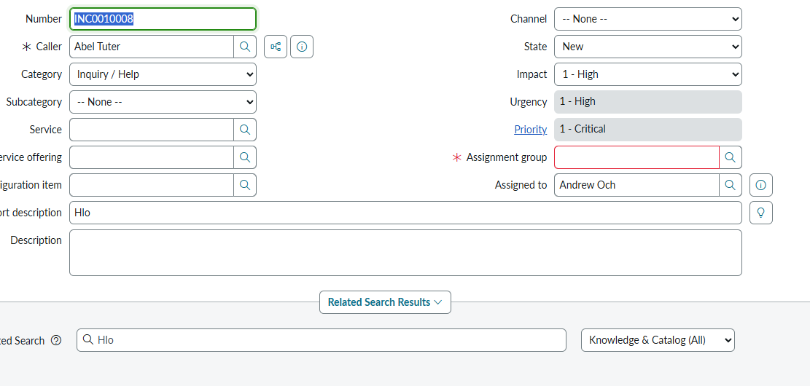
Place the screenshot showing the validation Client Script or resulting error behavior here if desired.

